
Convenient

Microsoft Dynamics Snap

Timesheet Management Snap-in

White Paper

Technical Pre-release Version 1.0 for Microsoft Dynamics TM AX 4.0 / 2007 Microsoft® Office system

February 10, 2007

Microsoft Dynamics Snap Sandbox

Table of Contents
Executive Summary 3
INTRODUCING MICROSOFT DYNAMICS SNAP 3
Microsoft Dynamics Snap for Timesheet Management 4
Functional overview 5
Filing Time Entries directly from the outlook Calendar 6
Planning activities using filed Time Entries 8
Viewing filed Time Entries linked to appointments 9
High level architecture 10
PRE-Requisites for using this Snap-in 10

Executive Summary
Many corporations implement business application systems like Microsoft Dynamics™ to automate their back-office business processes. Oftentimes though, it can be quite tedious to get information into those systems even requiring people to keep multiple records of the same activity which if course, gives rise to greater opportunity for errors. What if there were ways to enable information workers to get relevant data into their Microsoft Dynamics applications from within Microsoft Office?

INTRODUCING MICROSOFT DYNAMICS SNAP
Microsoft Dynamics Snap applications do just that—they allow information workers to interact easily with Microsoft Dynamics, thereby increasing their productivity and enabling them to get timely and accurate information into their system from within the Microsoft Office applications they are most comfortable with and with which they are most familiar. Microsoft Dynamics Snap applications help companies maximize their investment in Microsoft technology by delivering the power of the Microsoft Dynamics business applications to every single employee.

Microsoft Dynamics Snap for Timesheet Management

The Timesheet Management Snap-in allows Information Workers to use Microsoft Office Outlook appointments to keep track of time utilization. With this snap-in an Information Worker can periodically update the Microsoft Dynamics AX system directly from their Outlook Calendar eliminating the need for and possible errors from having to enter data in multiple places.

Using this Snap-in allows them to:
- Create Microsoft Dynamics AX time entries directly from the appointments entered in their Outlook Calendar.
- Populate those time entries automatically with the appointment details entered in Outlook; and refer back to those entries once they are made so that they can see what information was entered into the Microsoft Dynamics system.
- View a time utilization report for a specific period of time and group their time entries by project, time period or type of work.

In a matter of minutes, the Information Workers are able to enter their weekly time into the system, all from within the comfort of Outlook. This saves times and reduces errors. Additionally, they are able to get a better idea of how their time is being spent, so that they can increase their ability to plan time more efficiently.

Functional overview
Timesheet Management snap-in synchronizes schedules created in Microsoft Outlook to timesheets in Microsoft Dynamics AX 4.0. Here are the features of this application:
- View time entries already existing in Microsoft Dynamics AX 4.0 from Microsoft Outlook
- Submit new time entries for various tasks that are performed directly from Microsoft Outlook
- Submit appointments and meetings in Microsoft Outlook Calendar as time entries.
- Integrate Microsoft Dynamics AX 4.0 time entries with Microsoft Outlook appointments, auto-filling data and helping track changes made to linked appointments, saving time on manually correlating the two and reducing chances of erroneous information
Microsoft Outlook appointments are often used by business workers to record their time utilization information. Yet due to the nature of their jobs, many business workers also need to record this information in Microsoft Dynamics AX 4.0. Prior to the Timesheet Management snap-in, there was no easy way to use Outlook appointments to submit your time. Most users were forced to keep multiple records or to toggle back and forth between their Outlook calendar and the Microsoft Dynamics AX 4.0 client to enter the correct information.

The Timesheet Management Snap-in allows users to submit their time directly from their Outlook calendar, make entries that are not kept within that calendar, see summarized or detailed information on past time entries, and make changes to previously filed entries whether saved using the Microsoft Dynamics AX 4.0 client or Outlook.

Filing Time Entries directly from the outlook Calendar
A consultant, needs to enter his time in the Microsoft Dynamics AX system on a weekly basis. He manages all his meetings using the Microsoft Office Outlook calendar. With the Timesheet Management Snap-in, David can use the same Microsoft Office Outlook appointments he already keeps to get his time utilization reports into Microsoft Dynamics AX.

- Select the relevant appointments for a given period of time. Here is a snapshot of what the Microsoft Outlook Calendar might look like.
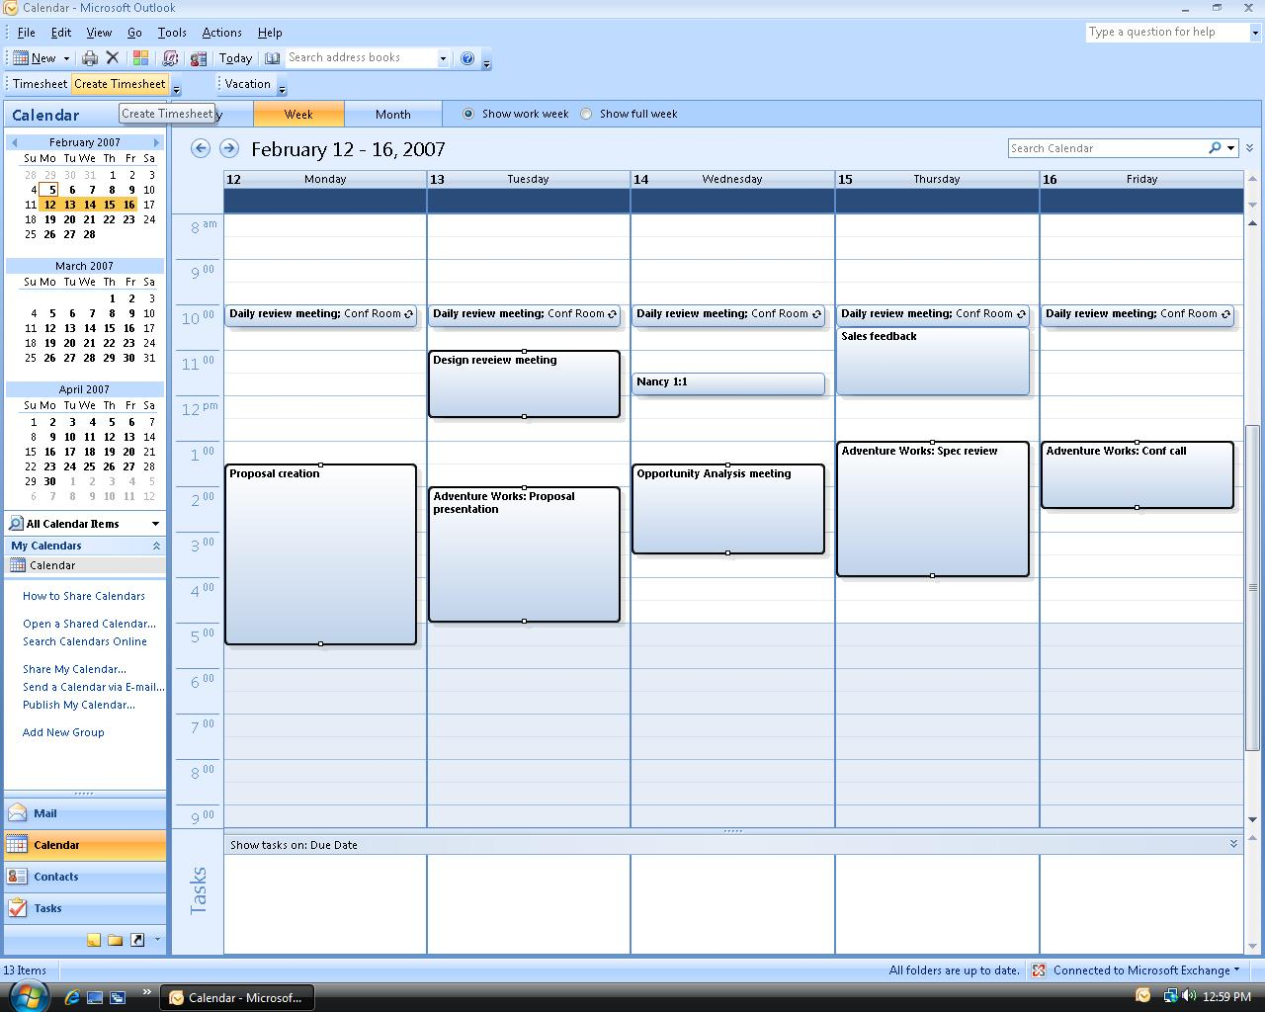

- Click the Create Timesheet toolbar button. The date, hours and notes data from details included in the selected appointments automatically populates the timesheet and the appointments are linked to the journal in Microsoft Dynamics AX 4.0. The user can add details by clicking on the New Line button. This what the Timesheet Entry Form would look like.

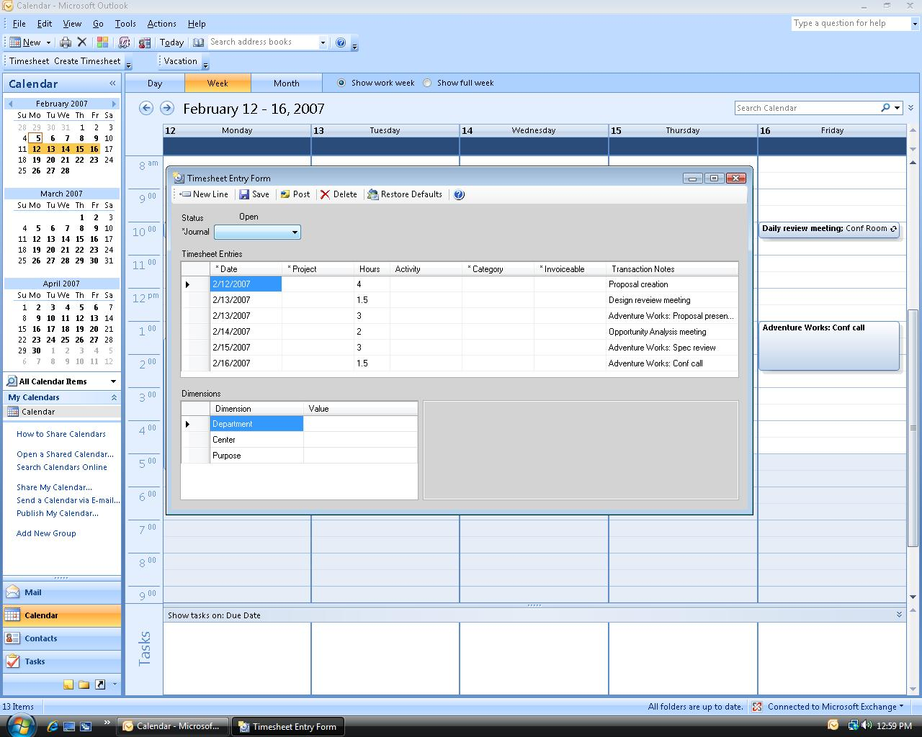

- A timesheet entry can also be created at the same time that you are creating an appointment in Microsoft Outlook Calendar. Click Create Timesheet on the appointment form to open a timesheet journal that is linked to the appointment.

Planning activities using filed Time Entries
In order to be more effective in planning his next week’s schedule, the consultant wants to have a look at how much time he has been spending on various activities. He can use the Timesheet Management snap-in to view his time utilization.

To view and manage time entry data or to file a time entry that has no corresponding appointment or meeting, click on the Timesheet in the toolbar to use the Timesheet History view in Outlook to view past entries made and the status of individual entries. Check Show in Groups to get a Summarized view. Select a particular entry and click on View details to get a detailed view or edit. File new time entries by clicking New Timesheet.
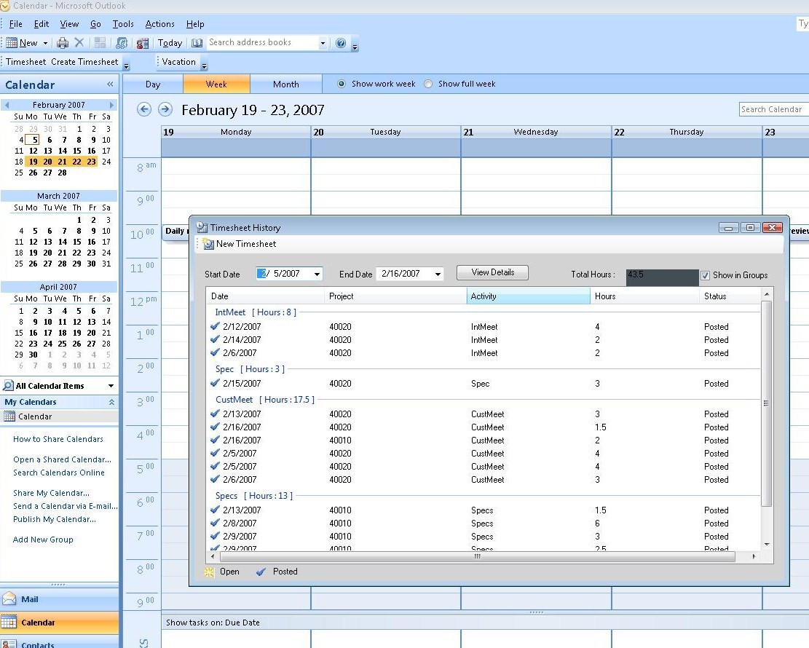

Viewing filed Time Entries linked to appointments
To view previously filed time entries from their corresponding appointments click on the appointment or meeting request to open it. Then, click Timesheet in the Snap ribbon to view filed time entries linked to this particular appointment.
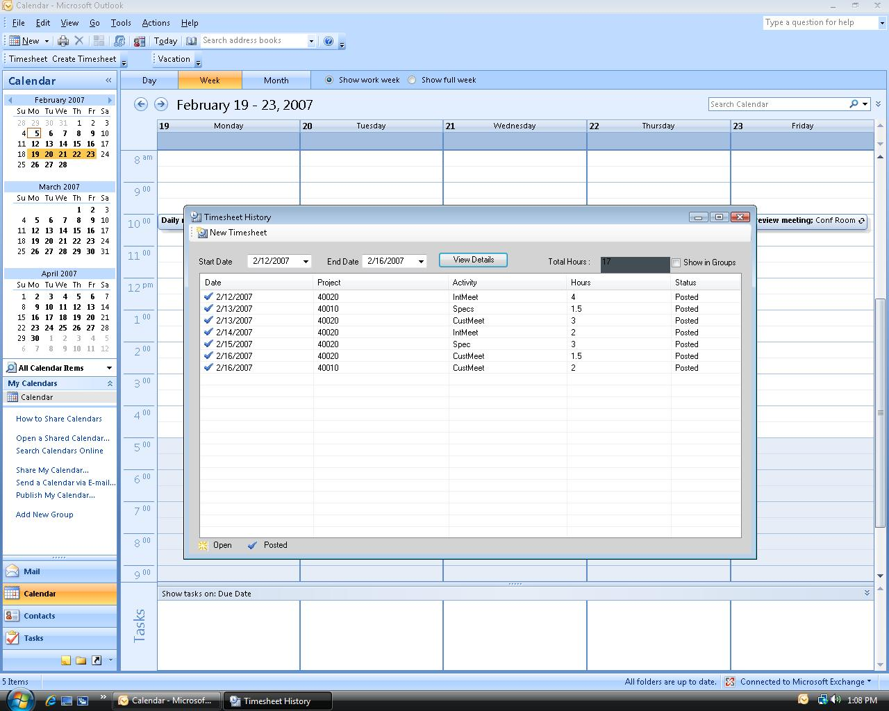

High level architecture

The Timesheet Management snap-in allows data from the Microsoft Outlook calendar to be entered in a timesheet. This data then gets replicated in Microsoft Dynamics AX 4.0 once this timesheet is submitted. The previous timesheets created by the user can also be viewed within Outlook.

The Timesheet management snap-in uses the Outlook Object Model (OOM) to add toolbar buttons in Outlook which serves as its entry point. Buttons are added to the ribbon in the mail item through the OOM. When one of these buttons is clicked, it invokes the Timesheet Management forms. The snap-in then retrieves or updates data into the Microsoft Dynamics AX 4.0 database using AX 4.0 Business Connector.

This is a diagram of the Timesheet Management architecture.
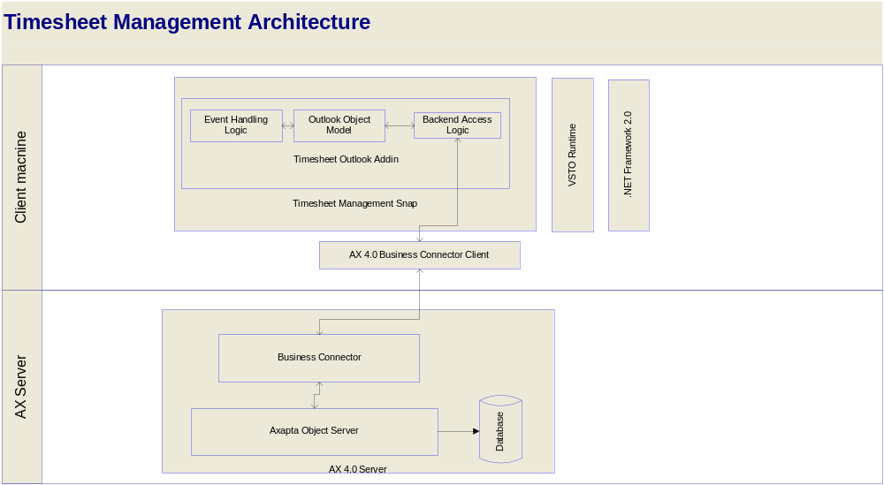

PRE-Requisites for using this Snap-in
- Microsoft Office 2007 should be installed, along with all the latest updates, and Microsoft Outlook should have been run at least once on the local machine
- Microsoft Dynamics AX 4.0 SP4 client and Business Connector 4.0 should be installed on the local machine with an active configuration that can access the Microsoft Dynamics AX 4.0 Server
- The user must have permissions and access to the Microsoft Dynamics AX 4.0 server
- Microsoft .NET Framework 2.0 should be installed on the system
- Microsoft VSTO 2005 SE Runtime should be installed on the system
The complete set of pre-requisites can be found in the installation guide.
Part No. 0000-0000 (02/07)
Microsoft Dynamics is a line of integrated, adaptable business management solutions that enables you and your people to make business decisions with greater confidence. Microsoft Dynamics works like and with familiar Microsoft software, automating and streamlining financial, customer relationship and supply chain processes in a way that helps you drive business success.

U.S. and Canada Toll Free 1-888-477-7989
Worldwide +1-701-281-6500
www.microsoft.com/dynamics
The information contained in this document represents the current view of Microsoft Corporation on the issues discussed as of the date of publication. Because Microsoft must respond to changing market conditions, this document should not be interpreted to be a commitment on the part of Microsoft, and Microsoft cannot guarantee the accuracy of any information presented after the date of publication.
This White Paper is for informational purposes only. MICROSOFT MAKES NO WARRANTIES, EXPRESS, IMPLIED, OR STATUTORY, AS TO THE INFORMATION IN THIS DOCUMENT.
Complying with all applicable copyright laws is the responsibility of the user. Without limiting the rights under copyright, no part of this document may be reproduced, stored in or introduced into a retrieval system, or transmitted in any form or by any means (electronic, mechanical, photocopying, recording, or otherwise), or for any purpose, without the express written permission of Microsoft Corporation.
Microsoft may have patents, patent applications, trademarks, copyrights, or other intellectual property rights covering subject matter in this document. Except as expressly provided in any written license agreement from Microsoft, the furnishing of this document does not give you any license to these patents, trademarks, copyrights, or other intellectual property.

© 2006 Microsoft Corporation. All rights reserved.
Microsoft, the Microsoft Dynamics Logo, Microsoft Office Outlook, BizTalk, Dexterity, FRx, Microsoft Dynamics, SharePoint, Visual Basic, Visual C++, Visual SourceSafe, Visual Studio, Windows, and Windows Server are either registered trademarks or trademarks of Microsoft Corporation, FRx Software Corporation, or Microsoft Business Solutions ApS in the United States and/or other countries. Microsoft Business Solutions ApS and FRx Software Corporation are subsidiaries of Microsoft Corporation.

